Types of machine learning problems
There are various ways to classify machine learning problems. Here, we discuss the most obvious ones.
1. On basis of the nature of the learning “signal” or “feedback” available to a learning system
- Supervised learning: The model or algorithm is presented with example inputs and their desired outputs and then finding patterns and connections between the input and the output. The goal is to learn a general rule that maps inputs to outputs. The training process continues until the model achieves the desired level of accuracy on the training data. Some real-life examples are:
  - Image Classification: You train with images/labels. Then in the future you give a new image expecting that the computer will recognize the new object.
  - Market Prediction/Regression: You train the computer with historical market data and ask the computer to predict the new price in the future.
- Unsupervised learning: No labels are given to the learning algorithm, leaving it on its own to find structure in its input. It is used for clustering population in different groups. Unsupervised learning can be a goal in itself (discovering hidden patterns in data).
  - Clustering: You ask the computer to separate similar data into clusters, this is essential in research and science.
  - High Dimension Visualization: Use the computer to help us visualize high dimension data.
  - Generative Models: After a model captures the probability distribution of your input data, it will be able to generate more data. This can be very useful to make your classifier more robust.
A simple diagram which clears the concept of supervised and unsupervised learning is shown below:
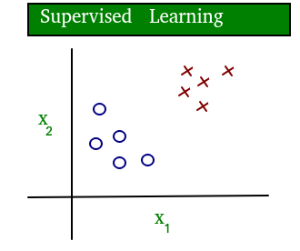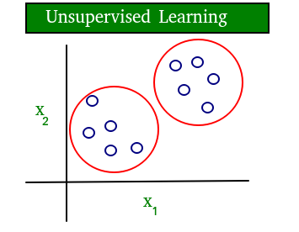
As you can see clearly, the data in supervised learning is labelled, where as data in unsupervised learning is unlabelled.
- Semi-supervised learning: Problems where you have a large amount of input data and only some of the data is labeled, are called semi-supervised learning problems. These problems sit in between both supervised and unsupervised learning. For example, a photo archive where only some of the images are labeled, (e.g. dog, cat, person) and the majority are unlabeled.
- Reinforcement learning: A computer program interacts with a dynamic environment in which it must perform a certain goal (such as driving a vehicle or playing a game against an opponent). The program is provided feedback in terms of rewards and punishments as it navigates its problem space.

2. Two most common use cases of Supervised learning are:
- Classification: Inputs are divided into two or more classes, and the learner must produce a model that assigns unseen inputs to one or more (multi-label classification) of these classes and predicting whether or not something belongs to a particular class. This is typically tackled in a supervised way. Classification models can be categorized in two groups: Binary classification and Multiclass Classification. Spam filtering is an example of binary classification, where the inputs are email (or other) messages and the classes are “spam” and “not spam”.
- Regression: It is also a supervised learning problem, that predicts a numeric value and outputs are continuous rather than discrete. For example, predicting the stock prices using historical data.
An example of classification and regression on two different datasets is shown below: 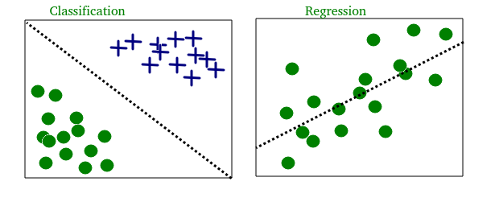
3. Most common Unsupervised learning are:
- Clustering: Here, a set of inputs is to be divided into groups. Unlike in classification, the groups are not known beforehand, making this typically an unsupervised task. As you can see in the example below, the given dataset points have been divided into groups identifiable by the colors red, green and blue.
- Density estimation: The task is to find the distribution of inputs in some space.
- Dimensionality reduction: It simplifies inputs by mapping them into a lower-dimensional space. Topic modeling is a related problem, where a program is given a list of human language documents and is tasked to find out which documents cover similar topics.
On the basis of these machine learning tasks/problems, we have a number of algorithms which are used to accomplish these tasks. Some commonly used machine learning algorithms are Linear Regression, Logistic Regression, Decision Tree, SVM(Support vector machines), Naive Bayes, KNN(K nearest neighbors), K-Means, Random Forest, etc. Note: All these algorithms will be covered in upcoming articles.
Terminologies of Machine Learning
- Model A model is a specific representation learned from data by applying some machine learning algorithm. A model is also called hypothesis.
- Feature A feature is an individual measurable property of our data. A set of numeric features can be conveniently described by a feature vector. Feature vectors are fed as input to the model. For example, in order to predict a fruit, there may be features like color, smell, taste, etc. Note: Choosing informative, discriminating and independent features is a crucial step for effective algorithms. We generally employ a feature extractor to extract the relevant features from the raw data.
- Target (Label) A target variable or label is the value to be predicted by our model. For the fruit example discussed in the features section, the label with each set of input would be the name of the fruit like apple, orange, banana, etc.
- Training The idea is to give a set of inputs(features) and it’s expected outputs(labels), so after training, we will have a model (hypothesis) that will then map new data to one of the categories trained on.
- Prediction Once our model is ready, it can be fed a set of inputs to which it will provide a predicted output(label). But make sure if the machine performs well on unseen data, then only we can say the machine performs well.
The figure shown below clears the above concepts:

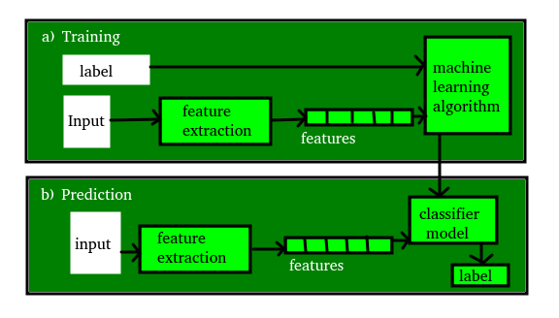
An introduction to Machine Learning
Definition of Machine Learning: Arthur Samuel, an early American leader in the field of computer gaming and artificial intelligence, coined the term “Machine Learning ” in 1959 while at IBM. He defined machine learning as “the field of study that gives computers the ability to learn without being explicitly programmed “. However, there is no universally accepted definition for machine learning. Different authors define the term differently. We give below two more definitions.

- Machine learning is programming computers to optimize a performance criterion using example data or past experience . We have a model defined up to some parameters, and learning is the execution of a computer program to optimize the parameters of the model using the training data or past experience. The model may be predictive to make predictions in the future, or descriptive to gain knowledge from data.
- The field of study known as machine learning is concerned with the question of how to construct computer programs that automatically improve with experience.
Definition of learning: A computer program is said to learn from experience E with respect to some class of tasks T and performance measure P , if its performance at tasks T, as measured by P , improves with experience E.
Examples
- Handwriting recognition learning problem
  - Task T : Recognizing and classifying handwritten words within images
  - Performance P : Percent of words correctly classified
  - Training experience E : A dataset of handwritten words with given classifications
- A robot driving learning problem
  - Task T : Driving on highways using vision sensors
  - Performance P : Average distance traveled before an error
  - Training experience E : A sequence of images and steering commands recorded while observing a human driver
Definition: A computer program which learns from experience is called a machine learning program or simply a learning program .

Classification of Machine Learning
Machine learning implementations are classified into four major categories, depending on the nature of the learning “signal” or “response” available to a learning system which are as follows:

A. Supervised learning:
Supervised learning is the machine learning task of learning a function that maps an input to an output based on example input-output pairs. The given data is labeled . Both classification and regression problems are supervised learning problems .
- Example — Consider the following data regarding patients entering a clinic . The data consists of the gender and age of the patients and each patient is labeled as “healthy” or “sick”.
gender | age | label
M | 48 | sick
M | 67 | sick
F | 53 | healthy
M | 49 | sick
F | 32 | healthy
M | 34 | healthy
M | 21 | healthy

B. Unsupervised learning:
Unsupervised learning is a type of machine learning algorithm used to draw inferences from datasets consisting of input data without labeled responses. In unsupervised learning algorithms, classification or categorization is not included in the observations. Example: Consider the following data regarding patients entering a clinic. The data consists of the gender and age of the patients.
gender | age
M | 48
M | 67
F | 53
M | 49
F | 34
M | 21
As a kind of learning, it resembles the methods humans use to figure out that certain objects or events are from the same class, such as by observing the degree of similarity between objects. Some recommendation systems that you find on the web in the form of marketing automation are based on this type of learning.
To know more about supervised and unsupervised learning refer to: –https://www.geeksforgeeks.org/supervised-unsupervised-learning/.

C. Reinforcement learning:
Reinforcement learning is the problem of getting an agent to act in the world so as to maximize its rewards.
A learner is not told what actions to take as in most forms of machine learning but instead must discover which actions yield the most reward by trying them. For example — Consider teaching a dog a new trick: we cannot tell it what tell it to do what to do, but we can reward/punish it if it does the right/wrong thing.
When watching the video, notice how the program is initially clumsy and unskilled but steadily improves with training until it becomes a champion.
To know more about Reinforcement learning refer to –https://www.geeksforgeeks.org/what-is-reinforcement-learning/.

D. Semi-supervised learning:
Where an incomplete training signal is given: a training set with some (often many) of the target outputs missing. There is a special case of this principle known as Transduction where the entire set of problem instances is known at learning time, except that part of the targets are missing. Semi-supervised learning is an approach to machine learning that combines small labeled data with a large amount of unlabeled data during training. Semi-supervised learning falls between unsupervised learning and supervised learning.

Categorizing based on required Output
Another categorization of machine learning tasks arises when one considers the desired output of a machine-learned system:
- Classification: When inputs are divided into two or more classes, the learner must produce a model that assigns unseen inputs to one or more (multi-label classification) of these classes. This is typically tackled in a supervised way. Spam filtering is an example of classification, where the inputs are email (or other) messages and the classes are “spam” and “not spam”. To know more about Classification, refer to –https://www.geeksforgeeks.org/regression-classification-supervised-machine-learning/
- Regression: Which is also a supervised problem, A case when the outputs are continuous rather than discrete. To know more about Classification, refer to –https://www.geeksforgeeks.org/regression-classification-supervised-machine-learning/ and https://www.geeksforgeeks.org/regression-classification-supervised-machine-learning/.
- Clustering: When a set of inputs is to be divided into groups. Unlike in classification, the groups are not known beforehand, making this typically an unsupervised task. To know more about Classification, refer to –https://www.geeksforgeeks.org/clustering-in-machine-learning/
Machine Learning comes into the picture when problems cannot be solved using typical approaches. ML algorithms combined with new computing technologies promote scalability and improve efficiency. Modern ML models can be used to make predictions ranging from outbreaks of disease to the rise and fall of stocks.
This article is contributed by Siddharth Pandey. If you like GeeksforGeeks and would like to contribute, you can also write an article using write.geeksforgeeks.org or mail your article to review-team@geeksforgeeks.org. See your article appearing on the GeeksforGeeks main page and help other Geeks.

ML | What is Machine Learning ?
Arthur Samuel, a pioneer in the field of artificial intelligence and computer gaming, coined the term “Machine Learning”. He defined machine learning as – a “Field of study that gives computers the capability to learn without being explicitly programmed”. In a very layman’s manner, Machine Learning(ML) can be explained as automating and improving the learning process of computers based on their experiences without being actually programmed i.e. without any human assistance. The process starts with feeding good quality data and then training our machines(computers) by building machine learning models using the data and different algorithms. The choice of algorithms depends on what type of data do we have and what kind of task we are trying to automate. Example: Training of students during exams. While preparing for the exams students don’t actually cram the subject but try to learn it with complete understanding. Before the examination, they feed their machine(brain) with a good amount of high-quality data (questions and answers from different books or teachers’ notes, or online video lectures). Actually, they are training their brain with input as well as output i.e. what kind of approach or logic do they have to solve a different kinds of questions. Each time they solve practice test papers and find the performance (accuracy /score) by comparing answers with the answer key given, Gradually, the performance keeps on increasing, gaining more confidence with the adopted approach. That’s how actually models are built, train machine with data (both inputs and outputs are given to the model), and when the time comes test on data (with input only) and achieve our model scores by comparing its answer with the actual output which has not been fed while training. Researchers are working with assiduous efforts to improve algorithms, and techniques so that these models perform even much better. Basic Difference in ML and Traditional Programming?

- Traditional Programming: We feed in DATA (Input) + PROGRAM (logic), run it on the machine, and get the output.
- Machine Learning: We feed in DATA(Input) + Output, run it on the machine during training and the machine creates its own program(logic), which can be evaluated while testing.
What does exactly learning mean for a computer? A computer is said to be learning from Experiences with respect to some class of Tasks if its performance in a given task improves with the Experience.
A computer program is said to learn from experience E with respect to some class of tasks T and performance measure P, if its performance at tasks in T, as measured by P, improves with experience E Example: playing checkers. E = the experience of playing many games of checkers T = the task of playing checkers. P = the probability that the program will win the next game In general, any machine learning problem can be assigned to one of two broad classifications: Supervised learning and Unsupervised learning. How things work in reality:-
- Talking about online shopping, there are millions of users with an unlimited range of interests with respect to brands, colors, price range, and many more. While online shopping, buyers tend to search for a number of products. Now, searching a product frequently will make buyers’ Facebook, web pages, search engines or online stores start recommending or showing offers on that particular product. There is no one sitting over there to code such a task for each and every user, all this task is completely automatic. Here, ML plays its role. Researchers, data scientists, and machine learners build models on the machine using good quality and a huge amount of data and now their machine is automatically performing and even improving with more and more experience and time. Traditionally, the advertisement was only done using newspapers, magazines and radio but now technology has made us smart enough to do Targeted advertisement (online ad system) which is a way more efficient method to target the most receptive audience.
- Even in health care also, ML is doing a fabulous job. Researchers and scientists have prepared models to train machines for detecting cancer just by looking at slide-cell images. For humans to perform this task it would have taken a lot of time. But now, no more delay, machines predict the chances of having or not having cancer with some accuracy and doctors just have to give an assurance call, that’s it. The answer to – how is this possible is very simple -all that is required, is, a high computation machine, a large amount of good quality image data, ML model with good algorithms to achieve state-of-the-art results. Doctors are using ML even to diagnose patients based on different parameters under consideration.
- You all might have to use IMDB ratings, Google Photos where it recognizes faces, Google Lens where the ML image-text recognition model can extract text from the images you feed in, and Gmail which categories E-mail as social, promotion, updates, or forums using text classification, which is a part of ML.
How does ML work?
- Gathering past data in any form suitable for processing. The better the quality of data, the more suitable it will be for modeling
- Data Processing – Sometimes, the data collected is in raw form and it needs to be pre-processed. Example: Some tuples may have missing values for certain attributes, and, in this case, it has to be filled with suitable values in order to perform machine learning or any form of data mining. Missing values for numerical attributes such as the price of the house may be replaced with the mean value of the attribute whereas missing values for categorical attributes may be replaced with the attribute with the highest mode. This invariably depends on the types of filters we use. If data is in the form of text or images then converting it to numerical form will be required, be it a list or array or matrix. Simply, Data is to be made relevant and consistent. It is to be converted into a format understandable by the machine
- Divide the input data into training, cross-validation, and test sets. The ratio between the respective sets must be 6:2:2
- Building models with suitable algorithms and techniques on the training set.
- Testing our conceptualized model with data that was not fed to the model at the time of training and evaluating its performance using metrics such as F1 score, precision, and recall.
  - Linear Algebra
  - Statistics and Probability
  - Calculus
  - Graph theory
  - Programming Skills – Languages such as Python, R, MATLAB, C++, or Octave

ML | Introduction to Data in Machine Learning
DATA: It can be any unprocessed fact, value, text, sound, or picture that is not being interpreted and analyzed. Data is the most important part of all Data Analytics, Machine Learning, Artificial Intelligence. Without data, we can’t train any model and all modern research and automation will go in vain. Big Enterprises are spending lots of money just to gather as much certain data as possible.

Example: Why did Facebook acquire WhatsApp by paying a huge price of $19 billion?
The answer is very simple and logical – it is to have access to the users’ information that Facebook may not have but WhatsApp will have. This information of their users is of paramount importance to Facebook as it will facilitate the task of improvement in their services.
INFORMATION: Data that has been interpreted and manipulated and has now some meaningful inference for the users.
KNOWLEDGE: Combination of inferred information, experiences, learning, and insights. Results in awareness or concept building for an individual or organization.
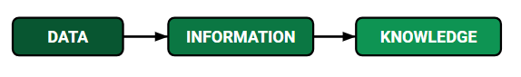
How we split data in Machine Learning?
- Training Data: The part of data we use to train our model. This is the data that your model actually sees(both input and output) and learns from.
- Validation Data: The part of data that is used to do a frequent evaluation of the model, fit on the training dataset along with improving involved hyperparameters (initially set parameters before the model begins learning). This data plays its part when the model is actually training.
- Testing Data: Once our model is completely trained, testing data provides an unbiased evaluation. When we feed in the inputs of Testing data, our model will predict some values(without seeing actual output). After prediction, we evaluate our model by comparing it with the actual output present in the testing data. This is how we evaluate and see how much our model has learned from the experiences feed in as training data, set at the time of training.
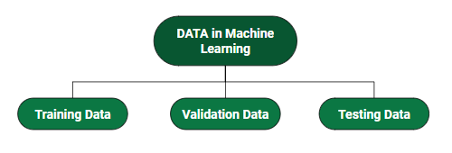
Consider an example:
There’s a Shopping Mart Owner who conducted a survey for which he has a long list of questions and answers that he had asked from the customers, this list of questions and answers is DATA. Now every time when he wants to infer anything and can’t just go through each and every question of thousands of customers to find something relevant as it would be time-consuming and not helpful. In order to reduce this overhead and time wastage and to make work easier, data is manipulated through software, calculations, graphs, etc. as per own convenience, this inference from manipulated data is Information. So, Data is a must for Information. Now Knowledge has its role in differentiating between two individuals having the same information. Knowledge is actually not technical content but is linked to the human thought process.
Different Forms of Data
- Numeric Data : If a feature represents a characteristic measured in numbers , it is called a numeric feature.
- Categorical Data : A categorical feature is an attribute that can take on one of the limited , and usually fixed number of possible values on the basis of some qualitative property . A categorical feature is also called a nominal feature.
- Ordinal Data : This denotes a nominal variable with categories falling in an ordered list . Examples include clothing sizes such as small, medium , and large , or a measurement of customer satisfaction on a scale from “not at all happy” to “very happy”.
Properties of Data –
- Volume: Scale of Data. With the growing world population and technology at exposure, huge data is being generated each and every millisecond.
- Variety: Different forms of data – healthcare, images, videos, audio clippings.
- Velocity: Rate of data streaming and generation.
- Value: Meaningfulness of data in terms of information that researchers can infer from it.
- Veracity: Certainty and correctness in data we are working on.
Some facts about Data:
- As compared to 2005, 300 times i.e. 40 Zettabytes (1ZB=10^21 bytes) of data will be generated by 2020.
- By 2011, the healthcare sector has a data of 161 Billion Gigabytes
- 400 Million tweets are sent by about 200 million active users per day
- Each month, more than 4 billion hours of video streaming is done by the users.
- 30 Billion different types of content are shared every month by the user.
- It is reported that about 27% of data is inaccurate and so 1 in 3 business idealists or leaders don’t trust the information on which they are making decisions.
The above-mentioned facts are just a glimpse of the actually existing huge data statistics. When we talk in terms of real-world scenarios, the size of data currently presents and is getting generated each and every moment is beyond our mental horizons to imagine.

Demystifying Machine Learning
Machine Learning”. Now that’s a word that packs a punch! Machine learning is hot stuff these days! And why won’t it be? Almost every “enticing” new development in the field of Computer Science and Software Development in general has something related to machine learning behind the veils. Microsoft’s Cortana – Machine Learning. Object and Face Recognition – Machine Learning and Computer Vision. Advanced UX improvement programs – Machine Learning (yes!. The Amazon product recommendation you just got was the number crunching effort of some Machine Learning Algorithm).

And not even just that. Machine Learning and Data Science in general is EVERYWHERE. It is as omnipotent as God himself, had he been into Computers! Why? Because Data is everywhere!
So it is natural, that anyone who has above average brains and can differentiate between Programming Paradigms by taking a sneak-peek at Code, is intrigued by Machine Learning.
But what is Machine Learning? And how big is Machine Learning? Let’s demystify Machine Learning, once and for all. And to do that, rather than presenting technical specifications, we’ll follow a “Understand by Example” approach.
Machine Learning : What is it really?
Well, Machine Learning is a subfield of Artificial Intelligence which evolved from Pattern Recognition and Computational Learning theory. Arthur Lee Samuel defines Machine Learning as: Field of study that gives computers the ability to learn without being explicitly programmed.
So, basically, the field of Computer Science and Artificial intelligence that “learns” from data without human intervention.
But this view has a flaw. As a result of this perception, whenever the word Machine Learning is thrown around, people usually think of “A.I.” and “Neural Networks that can mimic Human brains ( as of now, that is not possible)”, Self Driving Cars and what not. But Machine Learning is far beyond that. Below we uncover some expected and some generally not expected facets of Modern Computing where Machine Learning is in action.
Machine Learning: The Expected
We’ll start with some places where you might expect Machine Learning to play a part.
- Speech Recognition (Natural Language Processing in more technical terms) : You talk to Cortana on Windows Devices. But how does it understand what you say? Along comes the field of Natural Language Processing, or N.L.P. It deals with the study of interactions between Machines and Humans, via Linguistics. Guess what is at the heart of NLP: Machine Learning Algorithms and Systems ( Hidden Markov Models being one).
- Computer Vision : Computer Vision is a subfield of AI which deals with a Machine’s (probable) interpretation of the Real World. In other words, all Facial Recognition, Pattern Recognition, Character Recognition Techniques belong to Computer Vision. And Machine Learning once again, with it wide range of Algorithms, is at the heart of Computer Vision.
- Google’s Self Driving Car : Well. You can imagine what drives it actually. More Machine Learning goodness.
But these were expected applications. Even a naysayer would have a good insight about these feats of technology being brought to life by some “mystical (and extremely hard) mind crunching Computer wizardry”.
Machine Learning : The Unexpected
Let’s visit some places normal folks would not really associate easily with Machine Learning:
- Amazon’s Product Recommendations: Ever wondered how Amazon always has a recommendation that just tempts you to lighten your wallet. Well, that’s a Machine Learning Algorithm(s) called “Recommender Systems” working in the backdrop. It learns every user’s personal preferences and makes recommendations according to that.
- Youtube/Netflix : They work just as above!
- Data Mining / Big Data : This might not be so much of a shock to many. But Data Mining and Big Data are just manifestations of studying and learning from data at a larger scale. And wherever there’s the objective of extracting information from data, you’ll find Machine Learning lurking nearby.
- Stock Market/Housing Finance/Real Estate : All of these fields, incorporate a lot of Machine Learning systems in order to better assess the market, namely “Regression Techniques”, for things as mediocre as predicting the price of a House, to predicting and analyzing stock market trends.
So as you might have seen now. Machine Learning actually is everywhere. From Research and Development to improving business of Small Companies. It is everywhere. And hence it makes up for quite a career option, as the industry is on the rise and is the boon is not stopping any time soon.
So, this is it for now. This wraps up our Machine Learning 101. We’ll hopefully meet again, and when we do, we’ll dive into some technical details of Machine Learning, what tools are used in the industry, and how to start your journey to Machine Learning prowess. Till then, Code Away!

Machine Learning – Applications
Introduction

Machine learning is one of the most exciting technologies that one would have ever come across. As it is evident from the name, it gives the computer that which makes it more similar to humans: The ability to learn. Machine learning is actively being used today, perhaps in many more places than one would expect. We probably use a learning algorithm dozens of time without even knowing it. Applications of Machine Learning include:
- Web Search Engine: One of the reasons why search engines like google, bing etc work so well is because the system has learnt how to rank pages through a complex learning algorithm.
- Photo tagging Applications: Be it facebook or any other photo tagging application, the ability to tag friends makes it even more happening. It is all possible because of a face recognition algorithm that runs behind the application.
- Spam Detector: Our mail agent like Gmail or Hotmail does a lot of hard work for us in classifying the mails and moving the spam mails to spam folder. This is again achieved by a spam classifier running in the back end of mail application.
Today, companies are using Machine Learning to improve business decisions,increase productivity, detect disease, forecast weather, and do many more things. With the exponential growth of technology, we not only need better tools to understand the data we currently have, but we also need to prepare ourselves for the data we will have. To achieve this goal we need to build intelligent machines. We can write a program to do simple things. But for most of times Hardwiring Intelligence in it is difficult. Best way to do it is to have some way for machines to learn things themselves. A mechanism for learning – if a machine can learn from input then it does the hard work for us. This is where Machine Learning comes in action. Some examples of machine learning are:
- Database Mining for growth of automation: Typical applications include Web-click data for better UX( User eXperience), Medical records for better automation in healthcare, biological data and many more.
- Applications that cannot be programmed: There are some tasks that cannot be programmed as the computers we use are not modelled that way. Examples include Autonomous Driving, Recognition tasks from unordered data (Face Recognition/ Handwriting Recognition), Natural language Processing, computer Vision etc.
- Understanding Human Learning: This is the closest we have understood and mimicked the human brain. It is the start of a new revolution, The real AI. Now, After a brief insight lets come to a more formal definition of Machine Learning
- Arthur Samuel(1959): “Machine Learning is a field of study that gives computers, the ability to learn without explicitly being programmed.”Samuel wrote a Checker playing program which could learn over time. At first it could be easily won. But over time, it learnt all the board position that would eventually lead him to victory or loss and thus became a better chess player than Samuel itself. This was one of the most early attempts of defining Machine Learning and is somewhat less formal.
- Tom Michel(1999): “A computer program is said to learn from experience E with respect to some class of tasks T and performance measure P, if its performance at tasks in T, as measured by P, improves with experience E.” This is a more formal and mathematical definition. For the previous Chess program
  - E is number of games.
  - T is playing chess against computer.
  - P is win/loss by computer.
In the Next tutorial we shall classify the types of Machine Learning problems and shall also discuss about useful packages and setting environment for Machine Learning and how can we use it to design new projects.
References:
[1] Machine Learning in action by Peter Harrington.
[2] cs229.stanford.edu

Best Python libraries for Machine Learning
Machine Learning, as the name suggests, is the science of programming a computer by which they are able to learn from different kinds of data. A more general definition given by Arthur Samuel is – “Machine Learning is the field of study that gives computers the ability to learn without being explicitly programmed.” They are typically used to solve various types of life problems.
In the older days, people used to perform Machine Learning tasks by manually coding all the algorithms and mathematical and statistical formulas. This made the processing time consuming, tedious and inefficient. But in the modern days, it is become very much easy and efficient compared to the olden days with various python libraries, frameworks, and modules. Today, Python is one of the most popular programming languages for this task and it has replaced many languages in the industry, one of the reason is its vast collection of libraries. Python libraries that used in Machine Learning are:

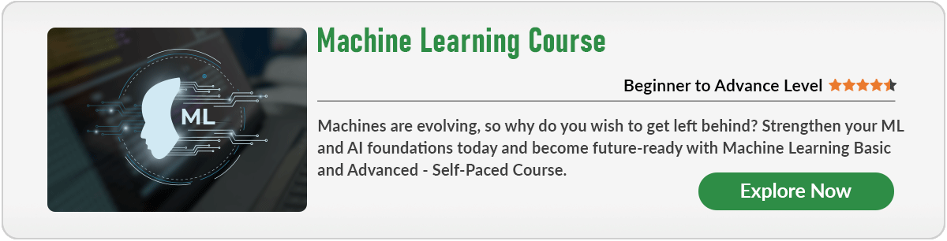
- Numpy
- Scipy
- Scikit-learn
- Theano
- TensorFlow
- Keras
- PyTorch
- Pandas
- Matplotlib

Numpy

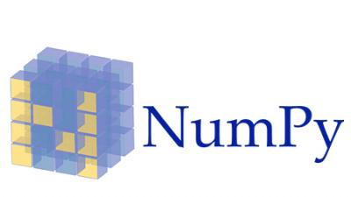
NumPy is a very popular python library for large multi-dimensional array and matrix processing, with the help of a large collection of high-level mathematical functions. It is very useful for fundamental scientific computations in Machine Learning. It is particularly useful for linear algebra, Fourier transform, and random number capabilities. High-end libraries like TensorFlow uses NumPy internally for manipulation of Tensors.

# Python program using NumPy
# for some basic mathematical
# operations

import numpy as np

# Creating two arrays of rank 2
x = np.array([[1, 2], [3, 4]])
y = np.array([[5, 6], [7, 8]])

# Creating two arrays of rank 1
v = np.array([9, 10])
w = np.array([11, 12])

# Inner product of vectors
print(np.dot(v, w), "\n")

# Matrix and Vector product
print(np.dot(x, v), "\n")

# Matrix and matrix product
print(np.dot(x, y))

Output:
219

[29 67]

[[19 22]
[43 50]]
For more details refer to Numpy.

SciPy


SciPy is a very popular library among Machine Learning enthusiasts as it contains different modules for optimization, linear algebra, integration and statistics. There is a difference between the SciPy library and the SciPy stack. The SciPy is one of the core packages that make up the SciPy stack. SciPy is also very useful for image manipulation.

# Python script using Scipy
# for image manipulation

from scipy.misc import imread, imsave, imresize

# Read a JPEG image into a numpy array
img = imread('D:/Programs / cat.jpg') # path of the image
print(img.dtype, img.shape)

# Tinting the image
img_tint = img * [1, 0.45, 0.3]

# Saving the tinted image
imsave('D:/Programs / cat_tinted.jpg', img_tint)

# Resizing the tinted image to be 300 x 300 pixels
img_tint_resize = imresize(img_tint, (300, 300))

# Saving the resized tinted image
imsave('D:/Programs / cat_tinted_resized.jpg', img_tint_resize)

Original image:

Tinted image:

Resized tinted image:

For more details refer to documentation.

Scikit-learn


Scikit-learn is one of the most popular ML libraries for classical ML algorithms. It is built on top of two basic Python libraries, viz., NumPy and SciPy. Scikit-learn supports most of the supervised and unsupervised learning algorithms. Scikit-learn can also be used for data-mining and data-analysis, which makes it a great tool who is starting out with ML.

# Python script using Scikit-learn
# for Decision Tree Classifier

# Sample Decision Tree Classifier
from sklearn import datasets
from sklearn import metrics
from sklearn.tree import DecisionTreeClassifier

# load the iris datasets
dataset = datasets.load_iris()

# fit a CART model to the data
model = DecisionTreeClassifier()
model.fit(dataset.data, dataset.target)
print(model)

# make predictions
expected = dataset.target
predicted = model.predict(dataset.data)

# summarize the fit of the model
print(metrics.classification_report(expected, predicted))
print(metrics.confusion_matrix(expected, predicted))

Output:
DecisionTreeClassifier(class_weight=None, criterion='gini', max_depth=None,
max_features=None, max_leaf_nodes=None,
min_impurity_decrease=0.0, min_impurity_split=None,
min_samples_leaf=1, min_samples_split=2,
min_weight_fraction_leaf=0.0, presort=False, random_state=None,
splitter='best')
precision recall f1-score support

0 1.00 1.00 1.00 50
1 1.00 1.00 1.00 50
2 1.00 1.00 1.00 50

micro avg 1.00 1.00 1.00 150
macro avg 1.00 1.00 1.00 150
weighted avg 1.00 1.00 1.00 150

[[50 0 0]
[ 0 50 0]
[ 0 0 50]]
For more details refer to documentation.

Theano


We all know that Machine Learning is basically mathematics and statistics. Theano is a popular python library that is used to define, evaluate and optimize mathematical expressions involving multi-dimensional arrays in an efficient manner. It is achieved by optimizing the utilization of CPU and GPU. It is extensively used for unit-testing and self-verification to detect and diagnose different types of errors. Theano is a very powerful library that has been used in large-scale computationally intensive scientific projects for a long time but is simple and approachable enough to be used by individuals for their own projects.

# Python program using Theano
# for computing a Logistic
# Function

import theano
import theano.tensor as T
x = T.dmatrix('x')
s = 1 / (1 + T.exp(-x))
logistic = theano.function([x], s)
logistic([[0, 1], [-1, -2]])

Output:
array([[0.5, 0.73105858],
[0.26894142, 0.11920292]])
For more details refer to documentation.

TensorFlow

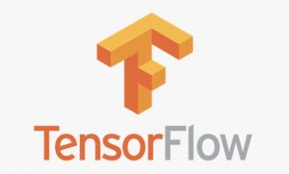
TensorFlow is a very popular open-source library for high performance numerical computation developed by the Google Brain team in Google. As the name suggests, Tensorflow is a framework that involves defining and running computations involving tensors. It can train and run deep neural networks that can be used to develop several AI applications. TensorFlow is widely used in the field of deep learning research and application.

# Python program using TensorFlow
# for multiplying two arrays

# import `tensorflow`
import tensorflow as tf

# Initialize two constants
x1 = tf.constant([1, 2, 3, 4])
x2 = tf.constant([5, 6, 7, 8])

# Multiply
result = tf.multiply(x1, x2)

# Initialize the Session
sess = tf.Session()

# Print the result
print(sess.run(result))

# Close the session
sess.close()

Output:
[ 5 12 21 32]
For more details refer to documentation.

Keras

 It provides many inbuilt methods for groping, combining and filtering data.
Keras is a very popular Machine Learning library for Python. It is a high-level neural networks API capable of running on top of TensorFlow, CNTK, or Theano. It can run seamlessly on both CPU and GPU. Keras makes it really for ML beginners to build and design a Neural Network. One of the best thing about Keras is that it allows for easy and fast prototyping.
For more details refer to documentation.

PyTorch


PyTorch is a popular open-source Machine Learning library for Python based on Torch, which is an open-source Machine Learning library which is implemented in C with a wrapper in Lua. It has an extensive choice of tools and libraries that supports on Computer Vision, Natural Language Processing(NLP) and many more ML programs. It allows developers to perform computations on Tensors with GPU acceleration and also helps in creating computational graphs.

# Python program using PyTorch
# for defining tensors fit a
# two-layer network to random
# data and calculating the loss

import torch

dtype = torch.float
device = torch.device("cpu")
# device = torch.device("cuda:0") Uncomment this to run on GPU

# N is batch size; D_in is input dimension;
# H is hidden dimension; D_out is output dimension.
N, D_in, H, D_out = 64, 1000, 100, 10

# Create random input and output data
x = torch.random(N, D_in, device = device, dtype = dtype)
y = torch.random(N, D_out, device = device, dtype = dtype)

# Randomly initialize weights
w1 = torch.random(D_in, H, device = device, dtype = dtype)
w2 = torch.random(H, D_out, device = device, dtype = dtype)

learning_rate = 1e-6
for t in range(500):
# Forward pass: compute predicted y
h = x.mm(w1)
h_relu = h.clamp(min = 0)
y_pred = h_relu.mm(w2)

# Compute and print loss
loss = (y_pred - y).pow(2).sum().item()
print(t, loss)

# Backprop to compute gradients of w1 and w2 with respect to loss
grad_y_pred = 2.0 * (y_pred - y)
grad_w2 = h_relu.t().mm(grad_y_pred)
grad_h_relu = grad_y_pred.mm(w2.t())
grad_h = grad_h_relu.clone()
grad_h[h < 0] = 0
grad_w1 = x.t().mm(grad_h)

# Update weights using gradient descent
w1 -= learning_rate * grad_w1
w2 -= learning_rate * grad_w2

Output:
0 47168344.0
1 46385584.0
2 43153576.0
...
...
...
497 3.987660602433607e-05
498 3.945609932998195e-05
499 3.897604619851336e-05
For more details refer to documentation.

Pandas


Pandas is a popular Python library for data analysis. It is not directly related to Machine Learning. As we know that the dataset must be prepared before training. In this case, Pandas comes handy as it was developed specifically for data extraction and preparation. It provides high-level data structures and wide variety tools for data analysis. It provides many inbuilt methods for grouping, combining and filtering data.

# Python program using Pandas for
# arranging a given set of data
# into a table

# importing pandas as pd
import pandas as pd

data = {"country": ["Brazil", "Russia", "India", "China", "South Africa"],
"capital": ["Brasilia", "Moscow", "New Delhi", "Beijing", "Pretoria"],
"area": [8.516, 17.10, 3.286, 9.597, 1.221],
"population": [200.4, 143.5, 1252, 1357, 52.98] }

data_table = pd.DataFrame(data)
print(data_table)

Output:
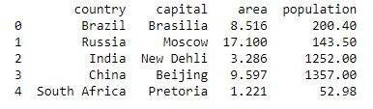
For more details refer to Pandas.

Matplotlib

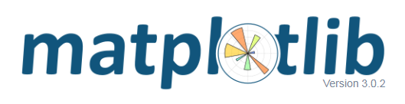
Matplotlib is a very popular Python library for data visualization. Like Pandas, it is not directly related to Machine Learning. It particularly comes in handy when a programmer wants to visualize the patterns in the data. It is a 2D plotting library used for creating 2D graphs and plots. A module named pyplot makes it easy for programmers for plotting as it provides features to control line styles, font properties, formatting axes, etc. It provides various kinds of graphs and plots for data visualization, viz., histogram, error charts, bar chats, etc,

# Python program using Matplotlib
# for forming a linear plot

# importing the necessary packages and modules
import matplotlib.pyplot as plt
import numpy as np

# Prepare the data
x = np.linspace(0, 10, 100)

# Plot the data
plt.plot(x, x, label ='linear')

# Add a legend
plt.legend()

# Show the plot
plt.show()

Output:
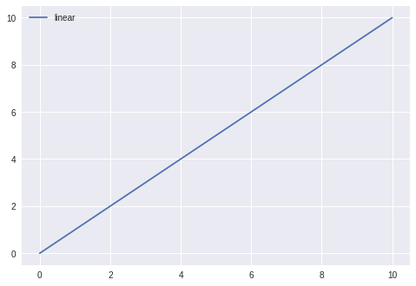
For more details refer to documentation.

Artificial Intelligence | An Introduction
Before leading to the meaning of artificial intelligence let understand what is the meaning of Intelligence-

Intelligence: The ability to learn and solve problems. This definition is taken from webster’s Dictionary.
The most common answer that one expects is “to make computers intelligent so that they can act intelligently!”, but the question is how much intelligent? How can one judge intelligence?
…as intelligent as humans. If the computers can, somehow, solve real-world problems, by improving on their own from past experiences, they would be called “intelligent”.
Thus, the AI systems are more generic(rather than specific), can “think” and are more flexible.
Intelligence, as we know, is the ability to acquire and apply knowledge. Knowledge is the information acquired through experience. Experience is the knowledge gained through exposure(training). Summing the terms up, we get artificial intelligence as the “copy of something natural(i.e., human beings) ‘WHO’ is capable of acquiring and applying the information it has gained through exposure.”
Intelligence is composed of:
- Reasoning
- Learning
- Problem Solving
- Perception
- Linguistic Intelligence
Many tools are used in AI, including versions of search and mathematical optimization, logic, and methods based on probability and economics. The AI field draws upon computer science, mathematics, psychology, linguistics, philosophy, neuroscience, artificial psychology, and many others.
Need for Artificial Intelligence
- To create expert systems that exhibit intelligent behavior with the capability to learn, demonstrate, explain, and advise its users.
- Helping machines find solutions to complex problems like humans do and applying them as algorithms in a computer-friendly manner.
Approaches of AI
There are a total of four approaches of AI and that are as follows:
- Acting humanly (The Turing Test approach): This approach was designed by Alan Turing. The ideology behind this approach is that a computer passes the test if a human interrogator, after asking some written questions, cannot identify whether the written responses come from a human or from a computer.
- Thinking humanly (The cognitive modeling approach): The idea behind this approach is to determine whether the computer thinks like a human.
- Thinking rationally (The “laws of thought” approach): The idea behind this approach is to determine whether the computer thinks rationally i.e. with logical reasoning.
- Acting rationally (The rational agent approach): The idea behind this approach is to determine whether the computer acts rationally i.e. with logical reasoning.
Applications of AI include Natural Language Processing, Gaming, Speech Recognition, Vision Systems, Healthcare, Automotive, etc.
An AI system is composed of an agent and its environment. An agent(e.g., human or robot) is anything that can perceive its environment through sensors and acts upon that environment through effectors. Intelligent agents must be able to set goals and achieve them. In classical planning problems, the agent can assume that it is the only system acting in the world, allowing the agent to be certain of the consequences of its actions. However, if the agent is not the only actor, then it requires that the agent can reason under uncertainty. This calls for an agent that cannot only assess its environment and make predictions but also evaluate its predictions and adapt based on its assessment. Natural language processing gives machines the ability to read and understand human language. Some straightforward applications of natural language processing include information retrieval, text mining, question answering, and machine translation. Machine perception is the ability to use input from sensors (such as cameras, microphones, sensors, etc.) to deduce aspects of the world. e.g., Computer Vision. Concepts such as game theory, and decision theory, necessitate that an agent can detect and model human emotions.
Many times, students get confused between Machine Learning and Artificial Intelligence, but Machine learning, a fundamental concept of AI research since the field’s inception, is the study of computer algorithms that improve automatically through experience. The mathematical analysis of machine learning algorithms and their performance is a branch of theoretical computer science known as a computational learning theory.
Stuart Shapiro divides AI research into three approaches, which he calls computational psychology, computational philosophy, and computer science. Computational psychology is used to make computer programs that mimic human behavior. Computational philosophy is used to develop an adaptive, free-flowing computer mind. Implementing computer science serves the goal of creating computers that can perform tasks that only people could previously accomplish.
AI has developed a large number of tools to solve the most difficult problems in computer science, like:
- Search and optimization
- Logic
- Probabilistic methods for uncertain reasoning
- Classifiers and statistical learning methods
- Neural networks
- Control theory
- Languages
High-profile examples of AI include autonomous vehicles (such as drones and self-driving cars), medical diagnosis, creating art (such as poetry), proving mathematical theorems, playing games (such as Chess or Go), search engines (such as Google search), virtual assistants (such as Siri), image recognition in photographs, spam filtering, prediction of judicial decisions[204] and targeted online advertisements. Other applications include Healthcare, Automotive, Finance, Video games, etc
Are there limits to how intelligent machines – or human-machine hybrids – can be? A superintelligence, hyperintelligence, or superhuman intelligence is a hypothetical agent that would possess intelligence far surpassing that of the brightest and most gifted human mind. ‘‘Superintelligence’’ may also refer to the form or degree of intelligence possessed by such an agent.
This article is contributed by Palak Jain. If you like GeeksforGeeks and would like to contribute, you can also write an article using write.geeksforgeeks.org or mail your article to review-team@geeksforgeeks.org. See your article appearing on the GeeksforGeeks main page and help other Geeks.

Machine Learning and Artificial Intelligence
Machine Learning and Artificial Intelligence are creating a huge buzz worldwide. The plethora of applications in Artificial Intelligence has changed the face of technology. The terms Machine Learning and Artificial Intelligence are often used interchangeably. However, there is a stark difference between the two that is still unknown to the industry professionals.
Let’s start by taking an example of Virtual Personal Assistants which have been familiar to most of us for quite some time now.

Working of Virtual Personal Assistants –
Siri(part of Apple Inc.’s iOS, watchOS, macOS, and tvOS operating systems), Google Now (a feature of Google Search offering predictive cards with information and daily updates in the Google app for Android and iOS.), Cortana (Cortana is a virtual assistant created by Microsoft for Windows 10) are intelligent digital personal assistants on the platforms like iOS, Android and Windows respectively. To put it plainly, they help to find relevant information when requested using voice. For instance, for answering queries like ‘What’s the temperature today?’ or ‘What is the way to the nearest supermarket’ etc. and the assistant will react by searching for information, transferring that information from the phone, or sending commands to various other applications.
AI is critical in these applications, as they gather data on the user’s request and utilize that data to perceive speech in a better manner and serve the user with answers that are customized to his inclination. Microsoft says that Cortana “consistently finds out about its user” and that it will in the end build up the capacity to anticipate users’ needs and cater to them. Virtual assistants process a tremendous measure of information from an assortment of sources to find out about users and be more compelling in helping them arrange and track their data. Machine learning is a vital part of these personal assistants as they gather and refine the data based on users’ past participation with them. Thereon, this arrangement of information is used to render results that are custom-made to users’ inclinations.
Roughly speaking, Artificial Intelligence (AI) is when a computer algorithm does intelligent work. On the other hand, Machine Learning is a part of AI that learns from the data that also involves the information gathered from previous experiences and allows the computer program to change its behavior accordingly. Artificial Intelligence is the superset of Machine Learning i.e. all Machine Learning is Artificial Intelligence but not all AI is Machine Learning.
Artificial Intelligence | Machine Learning
AI manages more comprehensive issues of automating a system. This computerization should be possible by utilizing any field such as image processing, cognitive science, neural systems, machine learning, etc. | Machine Learning (ML) manages to influence users’ machines to gain from the external environment. This external environment can be sensors, electronic segments, external storage gadgets, and numerous other devices.
AI manages the making of machines, frameworks, and different gadgets savvy by enabling them to think and do errands as all people generally do. | What ML does, depends on the user input or a query requested by the client, the framework checks whether it is available in the knowledge base or not. If it is available, it will restore the outcome to the user related to that query, however, if it isn’t stored initially, the machine will take in the user input and will enhance its knowledge base, to give a better value to the end-user
Future Scope –
- Artificial Intelligence is here to stay and is going nowhere. It digs out the facts from algorithms for a meaningful execution of various decisions and goals predetermined by a firm.
- Artificial Intelligence and Machine Learning are likely to replace the current model of technology that we see these days, for example, traditional programming packages like ERP and CRM are certainly losing their charm.
- Firms like Facebook, and Google are investing a hefty amount in AI to get the desired outcome at a relatively lower computational time.
- Artificial Intelligence is something that is going to redefine the world of software and IT in the near future.

Difference between Machine learning and Artificial Intelligence
Artificial Intelligence and Machine Learning are the terms of computer science. This article discusses some points on the basis of which we can differentiate between these two terms.

Artificial Intelligence comprises two words “Artificial” and “Intelligence”. Artificial refers to something which is made by humans or non natural thing and Intelligence means the ability to understand or think. There is a misconception that Artificial Intelligence is a system, but it is not a system. AI is implemented in the system. There can be so many definitions of AI, one definition can be “It is the study of how to train the computers so that computers can do things which at present humans can do better.” Therefore It is an intelligence that we want to add all the capabilities to a machine that human contains.
Machine Learning is the learning in which a machine can learn on its own without being explicitly programmed. It is an application of AI that provides the system the ability to automatically learn and improve from experience. Here we can generate a program by integrating the input and output of that program. One of the simple definitions of Machine Learning is “Machine Learning is said to learn from experience E w.r.t some class of task T and a performance measure P if learners performance at the task in the class as measured by P improves with experiences.”
The key difference between AI and ML are:
S. No. | ARTIFICIAL INTELLIGENCE | MACHINE LEARNING
1. | AI stands for Artificial intelligence, where intelligence is defined acquisition of knowledge intelligence is defined as the ability to acquire and apply knowledge. | ML stands for Machine Learning which is defined as the acquisition of knowledge or skill
2. | The aim is to increase the chance of success and not accuracy. | The aim is to increase accuracy, but it does not care about success
3. | AI is aiming to develop an intelligent system capable of performing a variety of complex jobs. | Machine learning is attempting to construct machines that can only accomplish the jobs for which they have been trained.
4. | It works as a computer program that does smart work. | Here, the tasks systems machine takes data and learns from data.
5. | The goal is to simulate natural intelligence to solve complex problems. | The goal is to learn from data on certain task to maximize the performance on that task.
6. | AI has a very broad variety of applications. | The scope of machine learning is constrained.
7. | AI is decision-making. | ML allows systems to learn new things from data.
8. | It is developing a system that mimics humans to solve problems. | It involves creating self-learning algorithms.
9. | AI will go for finding the optimal solution. | ML will go for a solution whether it is optimal or not.
10. | AI leads to intelligence or wisdom. | ML leads to knowledge.
11. | AI is a broader family consisting of ML and DL as its components. | ML is a subset of AI.
12. | Three broad categories of AI are :  - Artificial Narrow Intelligence (ANI)  - Artificial General Intelligence (AGI)  - Artificial Super Intelligence (ASI) | Three broad categories of ML are :  - Supervised Learning  - Unsupervised Learning  - Reinforcement Learning
13. | AI can work with structured, semi-structured, and unstructured data. | ML can work with only structured and semi-structured data.
14. | AI’s key uses include-  - Siri, customer service via catboats  - Expert Systems  - Machine Translation like Google Translate  - Intelligent humanoid robots such as Sophia, and so on. | The most common uses of machine learning-  - Facebook’s automatic friend suggestions  - Google’s search algorithms  - Banking fraud analysis  - Stock price forecast  - Online recommender systems, and so on.

Agents in Artificial Intelligence
Artificial intelligence is defined as the study of rational agents. A rational agent could be anything that makes decisions, as a person, firm, machine, or software. It carries out an action with the best outcome after considering past and current percepts(agent’s perceptual inputs at a given instance). An AI system is composed of an agent and its environment. The agents act in their environment. The environment may contain other agents.

An agent is anything that can be viewed as :
- perceiving its environment through sensors and
- acting upon that environment through actuators
Note: Every agent can perceive its own actions (but not always the effects)
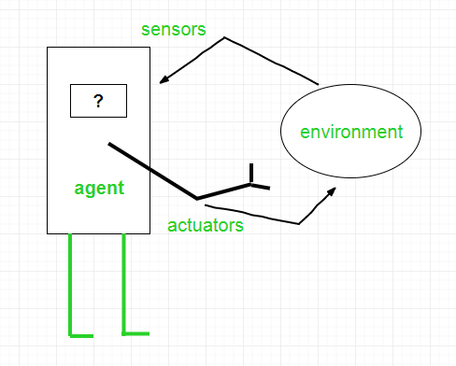
To understand the structure of Intelligent Agents, we should be familiar with Architecture and Agent programs. Architecture is the machinery that the agent executes on. It is a device with sensors and actuators, for example, a robotic car, a camera, a PC. Agent program is an implementation of an agent function. An agent function is a map from the percept sequence(history of all that an agent has perceived to date) to an action.
Agent = Architecture + Agent Program
Examples of Agent:
- A software agent has Keystrokes, file contents, received network packages which act as sensors and displays on the screen, files, sent network packets acting as actuators.
- A Human-agent has eyes, ears, and other organs which act as sensors, and hands, legs, mouth, and other body parts acting as actuators.
- A Robotic agent has Cameras and infrared range finders which act as sensors and various motors acting as actuators.
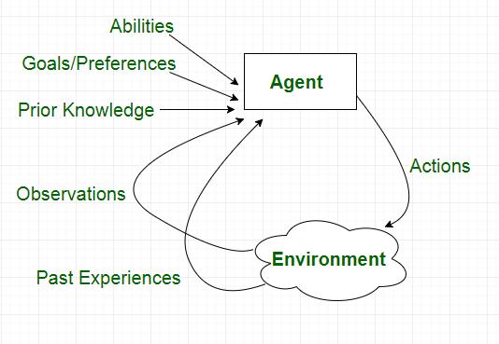

Types of Agents
Agents can be grouped into five classes based on their degree of perceived intelligence and capability :
- Simple Reflex Agents
- Model-Based Reflex Agents
- Goal-Based Agents
- Utility-Based Agents
- Learning Agent

Simple reflex agents
Simple reflex agents ignore the rest of the percept history and act only on the basis of the current percept. Percept history is the history of all that an agent has perceived to date. The agent function is based on the condition-action rule. A condition-action rule is a rule that maps a state i.e, condition to an action. If the condition is true, then the action is taken, else not. This agent function only succeeds when the environment is fully observable. For simple reflex agents operating in partially observable environments, infinite loops are often unavoidable. It may be possible to escape from infinite loops if the agent can randomize its actions.
Problems with Simple reflex agents are :
- Very limited intelligence.
- No knowledge of non-perceptual parts of the state.
- Usually too big to generate and store.
- If there occurs any change in the environment, then the collection of rules need to be updated.

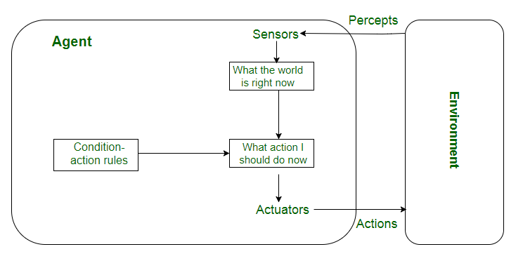

Model-based reflex agents
It works by finding a rule whose condition matches the current situation. A model-based agent can handle partially observable environments by the use of a model about the world. The agent has to keep track of the internal state which is adjusted by each percept and that depends on the percept history. The current state is stored inside the agent which maintains some kind of structure describing the part of the world which cannot be seen.
Updating the state requires information about :
- how the world evolves independently from the agent, and
- how the agent’s actions affect the world.

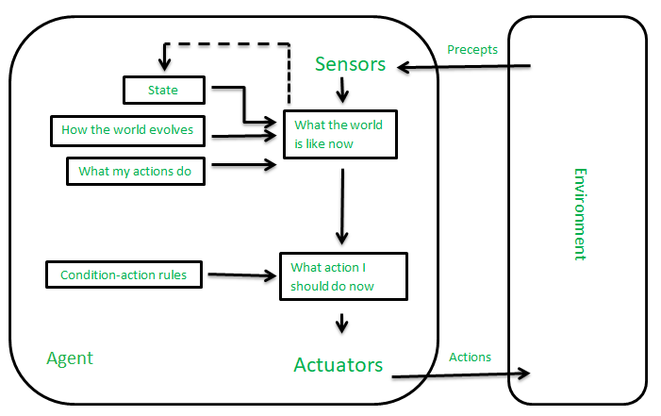

Goal-based agents
These kinds of agents take decisions based on how far they are currently from their goal(description of desirable situations). Their every action is intended to reduce its distance from the goal. This allows the agent a way to choose among multiple possibilities, selecting the one which reaches a goal state. The knowledge that supports its decisions is represented explicitly and can be modified, which makes these agents more flexible. They usually require search and planning. The goal-based agent’s behavior can easily be changed.
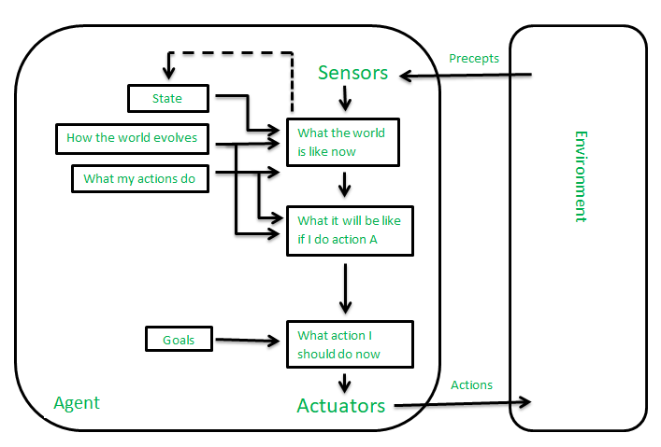

Utility-based agents
The agents which are developed having their end uses as building blocks are called utility-based agents. When there are multiple possible alternatives, then to decide which one is best, utility-based agents are used. They choose actions based on a preference (utility) for each state. Sometimes achieving the desired goal is not enough. We may look for a quicker, safer, cheaper trip to reach a destination. Agent happiness should be taken into consideration. Utility describes how “happy” the agent is. Because of the uncertainty in the world, a utility agent chooses the action that maximizes the expected utility. A utility function maps a state onto a real number which describes the associated degree of happiness.
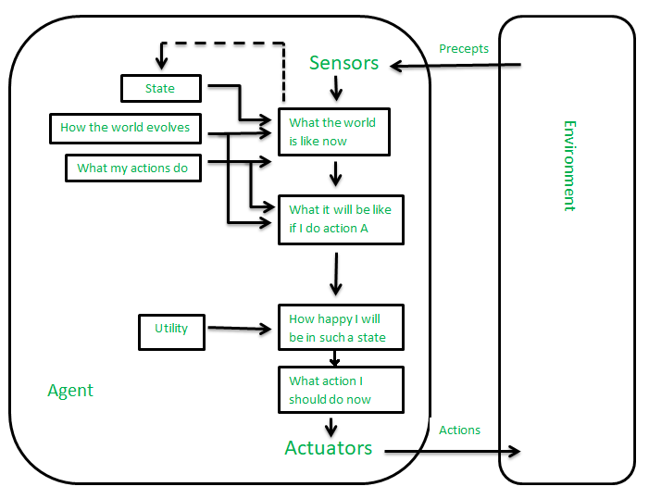

Learning Agent :
A learning agent in AI is the type of agent that can learn from its past experiences or it has learning capabilities. It starts to act with basic knowledge and then is able to act and adapt automatically through learning.
A learning agent has mainly four conceptual components, which are:
- Learning element: It is responsible for making improvements by learning from the environment
- Critic: The learning element takes feedback from critics which describes how well the agent is doing with respect to a fixed performance standard.
- Performance element: It is responsible for selecting external action
- Problem Generator: This component is responsible for suggesting actions that will lead to new and informative experiences.

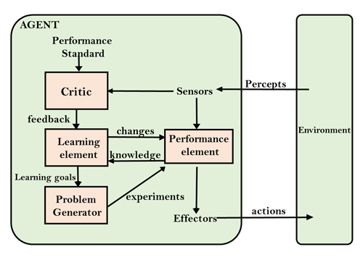

10 Basic Machine Learning Interview Questions
- Explain the difference between supervised and unsupervised machine learning? In supervised machine learning algorithms, we have to provide labeled data, for example, prediction of stock market prices, whereas in unsupervised we do not have labeled data where we group the unlabeled data, for example, conducting market segmentation.
- Explain the difference between KNN and K-Means clustering? K-Nearest Neighbours is a supervised machine learning algorithm where we need to provide the labeled data to the model it then classifies the points based on the distance of the point from the nearest points. Whereas, on the other hand, K-Means clustering is an unsupervised machine learning algorithm thus we need to provide the model with unlabelled data and this algorithm classifies points into clusters based on the mean of the distances between different points.
- What is the difference between classification and regression? Classification is used to produce discrete results, classification is used to classify data into some specific categories .for example classifying e-mails into spam and non-spam categories. Whereas, We use regression analysis when we are dealing with continuous data, for example predicting stock prices at a certain point of time.
- How to ensure that your model is not overfitting? Keep the design of the model simple. Try to reduce the noise in the model by considering fewer variables and parameters. Cross-validation techniques such as K-folds cross-validation help us keep overfitting under control. Regularization techniques such as LASSO help in avoiding overfitting by penalizing certain parameters if they are likely to cause overfitting.
- What are the different sets in which we divide any dataset for Machine Learning? For any ML application, we divide our dataset into three segments namely ‘Training Set’, ‘Validation Set’ & ‘Testing Set’. Training Set is used for training the ML model, Validation Set is used for Hyperparameter tuning and Testing Set is used for testing the model to see how well it is performing.
- List the main advantage of Naive Bayes? A Naive Bayes classifier converges very quickly as compared to other models like logistic regression. As a result, we need less training data in the case of a naive Bayes classifier.
- Explain Ensemble learning. In ensemble learning, many base models like classifiers and regressors are generated and combined together so that they give better results. It is used when we build component classifiers that are accurate and independent. There are sequential as well as parallel ensemble methods.
- Explain Dimensionality Reduction in machine learning. Dimensionality Reduction is the method of reducing the number of dimensions of any dataset by reducing the number of features. It is important because as we move into higher dimensions, the datapoints start becoming equidistant from each other which can affect the performance of unsupervised ML algorithms which use euclidean distance as the similarity function to classify datapoints. This is known as the Curse of Dimensionality. Also, it is difficult to visualize data beyond 4 dimensions.
- What should you do when your model is suffering from low bias and high variance? When the model is suffering from low bias and high variance, it is essentially overfitting, where the accuracy of train dataset is much higher than the accuracy of the test dataset. In such a situation, techniques such as Regularization can be used or the model can be simplified by reducing the number of features in the dataset.
- Explain the differences between random forest and gradient boosting algorithms. Random forest uses bagging techniques whereas GBM uses boosting techniques. Random forests mainly try to reduce variance and GBM reduces both bias and variance of a model.

